HADLEY, MICHAEL

Teesside University  [Company address]

Final Year Project Report

Contents

References: 2

Games assets:

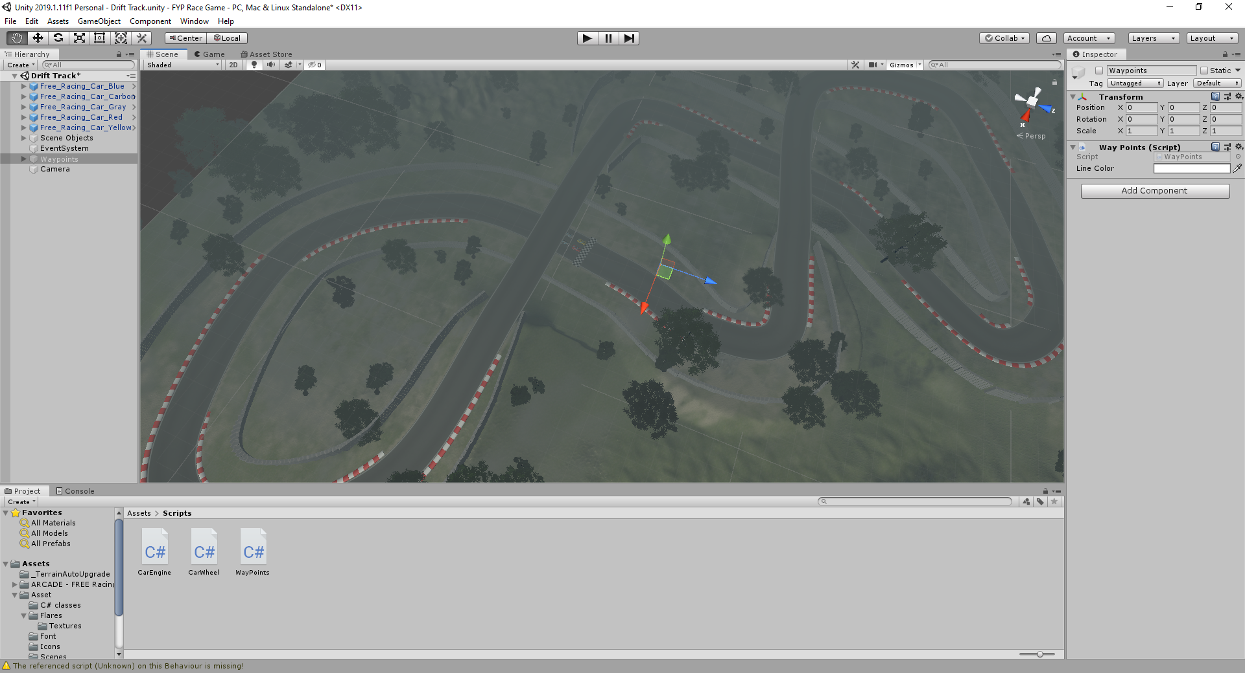

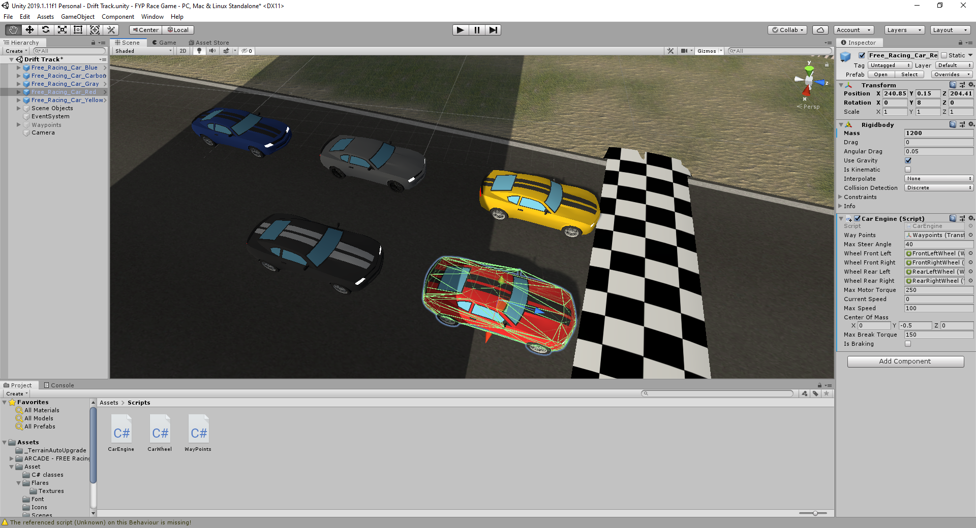

Created the waypoints for the AI cars to follow. Thursday 5th March 2020

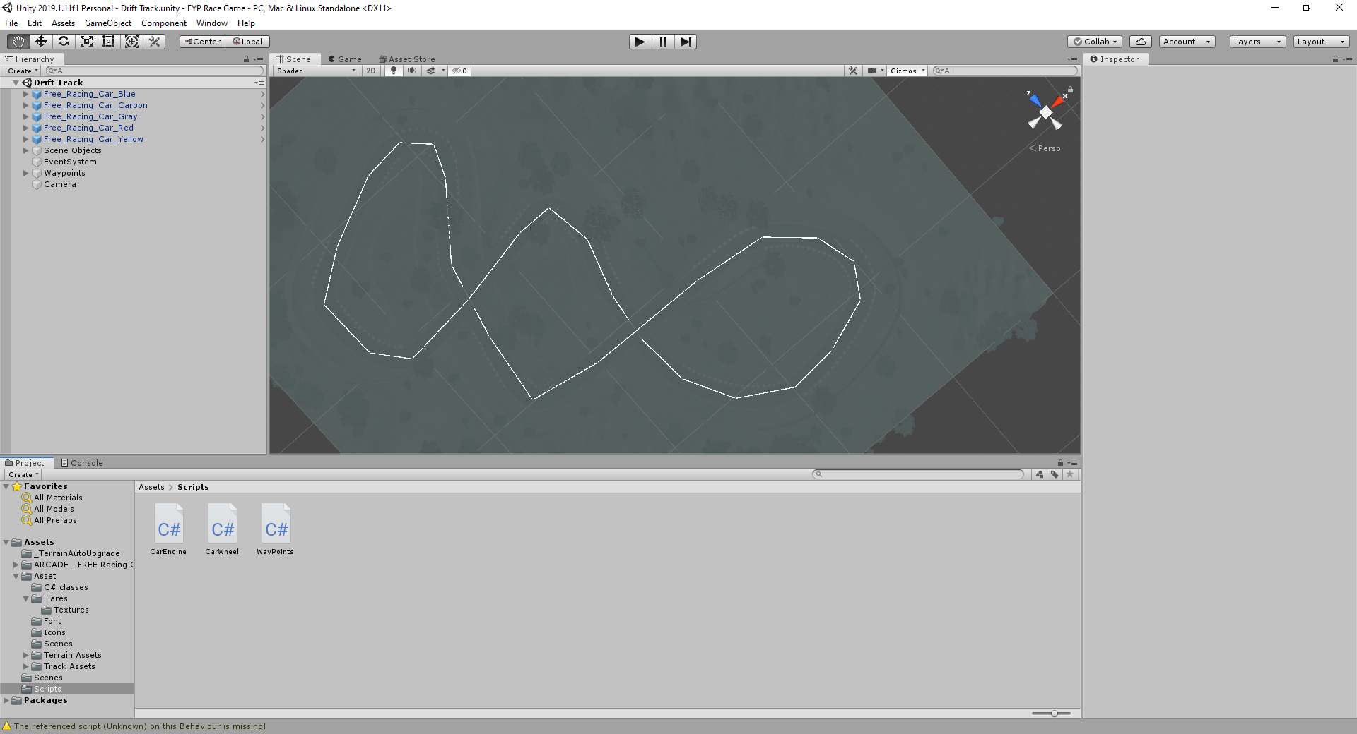

Wheel colliders Sunday 8th March 2020. So that the car turn and drive around the map.

Monday 9th March: Implemented the code to allow the cars to drive to the nearest checkpoint but they currently cannot complete a full lap as they drive off the track and crash.

# References:

<https://assetstore.unity.com/packages/3d/environments/roadways/race-tracks-140501>

Author: Abdul Rahim

Asset Pack: Race Tracks

Accessed 06/02/2020

<https://assetstore.unity.com/packages/3d/vehicles/land/arcade-free-racing-car-161085>

Author: iMENA Games

Asset Pack: Arcade: Free Racing Car

Accessed 06/02/20